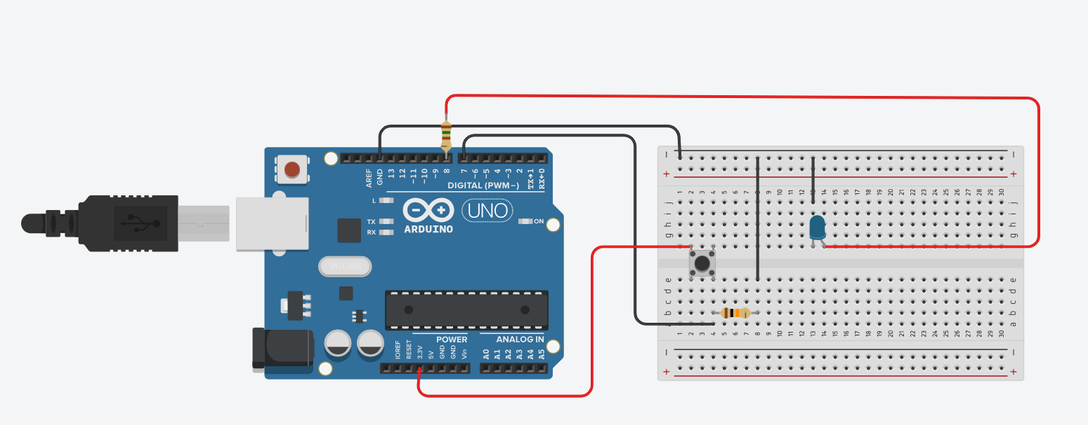unsigned const LED = 8;
unsigned const BUTTON = 7;
unsigned int bState = 0;
void setup()
{
pinMode(BUTTON, INPUT);
pinMode(LED, OUTPUT);
}
void loop()
{
if(digitalRead(BUTTON) == 1) {
digitalWrite(LED, HIGH);
bState += 1;
if(bState % 2 == 0){
digitalWrite(LED, LOW);
bState = 0;
}
delay(100);
}
}

